**Snowsport England **

*Freestyle Selection Policy*

**1. Selection Policy**

1.1. This Policy for selection to English Freestyle Squad, shall apply with effect from

January 2015 until further notice.

1.2. The reason for the changes is to provide a clear measurable standard for entry into the

Teams and Academies.

1.3. Once an athlete has progressed to the British Team they will remain an honoury

member of the English Team/Academy.

**2. Aims of the Selection Policy**

2.1. To ensure that fair and just criteria and practices are employed for the selection of

squad members.

2.2. To support the overall competition and development objectives of Snowsport

England.

2.3. To ensure transparency and accountability in the Selection process.

**3. Process and Timetable**

3.1. Selections will normally be made in, but not limited to, May after the British Freestyle

Championships on snow.

3.2. Meetings other than the May meeting will normally be used only to add to or upgrade

selections already made, and not to de-select individuals.

3.3. Current members of English Teams together with athletes competing internationally will automatically be considered for re-selection/selection. While other athletes with suitable results may be considered, all are advised to apply to the English Freestyle Selection Committee, stating their competition and training plans for the coming season.

3.4 Injuries will be taken into consideration for squad selection/ reselection if received in

writing.

**4. Selection to English Teams**

**4.1 B Team Selection for Ski Cross and Aerials**

4.1.1 Have competed in snow events and training on mountain snow. (Excluding Aerials.)

4.1.2 The selectors will use all resources at their disposal to satisfy themselves that the candidate has the wish and ability to eventually reach the British Team. Current information found that indicates the candidate has no or almost insignificant chance of this would not be selected.

4.1.3 Must have a FIS C licence. Should the candidate not have one, then they must apply and have the licence before the team place can be confirmed.

4.1.4 Those who have not progressed to the A team after 2 years in the

B team will not be re-selected. Those who have been

de-selected may be re-selected for the higher A team at a future date.

4.1.5 Behave in a manner expected of an individual representing their country.

4.1.6 For **Ski Cross**, athletes must have demonstrated a suitable level of performance whilst competing in the senior (open) category at a British Championships, Home Nation Championships or comparable mountain event (e.g. Audi Ski Cross Tour). Typically the athlete should have achieved a qualifying time within 5% of the race leader at this level, although exceptions may be made at selectors’ discretion.

4.1.7 For **Aerials** must be qualified to perform on snow two different manoeuvres

with a Degree Of Difficulty of at least 2.0

**4.2 A Team Selection for Ski Cross and Aerials**

4.2.1 The selectors will use all resources at their disposal to satisfy themselves that the candidate has the wish and ability to eventually reach the British Team. Current information found that indicates the candidate has no or almost insignificant chance of this, would not be selected.

4.2.2 Must have a FIS B licence

4.2.3 Behave in a manner expected of an individual representing their country.

4.2.4 Provide, if required, video evidence of their performance.

4.2.5 Reselection to A squad status is dependent on participation in snow

competitions in the most recent competitive season in either the Northern

or Southern Hemispheres.

4.2.6 For **Ski Cross** must have competed at Europa Cup level, equivalent or above

or in none FIS events of an equivalent level i.e. Must have met the criteria

for a FIS B License (refer [www.freestylesnowsports.co.uk](http://www.freestylesnowsports.co.uk) and click on "document download" then select "[BSS Selection Criteria 2014.pdf](https://www.dropbox.com/sh/by1ph8x9p578uyg/AAAClPix_bs7YQ7gG_Db8rjGa/BSS%20Selection%20Criteria%202014.pdf?dl=0)" for download) For clarity not only must the candidate meet the criteria for a FIS B licence, but they must have entered at least one event at this level.

4.2.10 For **Aerials** must have competed at Europa Cup level, equivalent or above

i.e. Must have met the criteria for a FIS B Licence ( refer [www.freestylesnowsports.co.uk](http://www.freestylesnowsports.co.uk) and click on "document download" then select "[BSS Selection Criteria 2014.pdf](https://www.dropbox.com/sh/by1ph8x9p578uyg/AAAClPix_bs7YQ7gG_Db8rjGa/BSS%20Selection%20Criteria%202014.pdf?dl=0)" for download) For clarity not only must the candidate meet the criteria for a FIS B licence, but they must have entered at least one event at this level.

**5. Selection to Mogul Academies**

**5.1 Process and Timetable**

Selections will normally be made in May, but not limited to, after the British Championships in March.

All athletes will be require to apply each season by 11 April by completing the online application form and including video footage in support of their application.

Successful athletes will be named in May after the Athletic Capacity Evaluations.

There will be a second application window for new athletes only which will close on the 30 Sept. Any successful athletes will be invited to train with the squad for the rest of the season but are not formally selected until successful reapplication in May.

**5.2 Code of Conduct**

All athletes will be required to sign and abide by a Code of Conduct, Concussion Protocol and Camp Booking Conditions. Agreement to both of these will be required to submit the online application form.

**5.3. Formation and Members of Selection Committee**

The Chairman of the Selection Committee may invite others with specialist knowledge to contribute for part of a meeting depending on the availability of the individual members and the specific areas for which it is selecting. Committee members should be free from external conflicts of interest in the selection process.

**5.4 England Academy for Moguls**

Selection to the National Moguls Academy has three components.

**5.4.1 Minimum Standard**

Athletes must be 10 years old or above and have competed in a minimum of two moguls competition either indoor or outdoor in the last twelve months. Athletes who have not competed in moguls may submit evidence of skiing performance, either in another discipline or freeskiing for consideration by the coaches.

**5.4.2 Skiing Skills Evaluation**

Athletes who meet the minimum standard will then be invited to carry out a skills assessment with the England and GB Moguls Coaches.

**5.4.3 Athletes Skill standards**

Athletes must achieve a minimum of 5 Refinement with a maximum of 1 Acquisition.

|  |  |  |  |
| --- | --- | --- | --- |
| **Skill (to be completed both in and out of the moguls)** | Acquisition (Red) | Consolidation (Amber) | Refinement (Green) |
| **Stance/Balance**  (Athletic balance and stance in a variety of conditions, both on piste and in moguls, demonstrated through a variety of exercises, performed with and without poles, as well as independent single ski exercises) |  |  |  |
| **Edging**  (Athletes must be able to demonstrate the ability to both skid and carve skis in a variety of conditions) |  |  |  |
| **Rotational skills**  (Athletes should demonstrate strong rotational skills in exercises such as braquage and also in basic jumps such as twisters) |  |  |  |
| **Initiation of turn**  (Athletes should be able to initiate the turn in a variety of conditions through up unweighting and down unweighting in a variety of conditions) |  |  |  |
| **Turn execution (in moguls)**  (Athletes should demonstrate  control, adaptability and agility in the moguls in order to execute a variety of turns) |  |  |  |
| **Turn execution (out of moguls)**  (Athletes should demonstrate  control, adaptability and agility on piste in order to execute a variety of turns) |  |  |  |
| **Completion of turn**  Athletes should be able to complete a turn appropriately in order to control descent, speed and line without losing control. |  |  |  |
| **Pole planting (in moguls)**  (Athletes should be able to ski moguls planting poles on the face, crest or backside of the moguls. They should also be able to ski moguls without poles) |  |  |  |
| **Tactics – line choice**  (Athletes should be able to maintain a skiing line or switch according to the exercise selected by the coach) |  |  |  |
| **Tactics – adaptation skills**  (Athletes should be able to demonstrate a variety of turns in moguls using the fall fill(line?), shoulders or crest/spine of the moguls) |  |  |  |

**5.4.4** Athletes who complete the above evaluations will then be invited to join the England Moguls Academy. Once in the England Moguls Academy the following support will be offered, please note that financial contributions may be needed.

5.4.4.1 Provide regular high-quality technical coaching leading to on-snow (mountain environment) training and competition

5.4.4.2 Introduction to “the athletic lifestyle” and “becoming an athlete”

5.4.4.3 Support cross-over and transfer athletes from other disciplines

4.4.4.4 Invite athletes to “snow-camp”

5.4.4.5 Provide guidance and support to athletes and parents

**5.4.5** Athletes in the England Moguls Academy who achieve a judges' score of a minimum of 40.0 in the British Championships, Home Nation Championships or similar snow competitions at a comparable or higher level, including open events run by other nations may apply to British Ski and Snowboard for a FIS C licence to enable them to compete in certain FIS Moguls Competitions.

**5.5 National Academy for Moguls**

**5.5.1** Selection for the National Academy for Moguls is based on athletes’ performance in Moguls competitions. Athletes are expected to achieve;

Three instances of a judges’ score of 50.0 or more in either FIS Race, World Junior Ski Championships, other FIS competition at C level or higher or the British Freestyle Championships. The candidate must also be securely and consistently performing in competition, one rotational air if female and two rotational airs if male. Rotational airs include upright rotations, off axis airs, loops, back and front flips

**5.5.2** Athletes who are selected to the National Academy for Moguls will receive the following;

5.5.2.1 Off-season support through UK based training/competitions alongside athletes in the England Moguls Academy

5.5.2.2 Provide regular on snow-training and key competition support to athletes

5.5.2.3 Provide support to athletes who are in external programmes (Club, College, Other National Team)

5.5.2.4 Develop S&C and performance lifestyle support services to athletes

5.5.2.5 Prepare athletes for progression to BSS Squads though FIS/NorAm/EC

## 5.6 Moguls Jump Skills Tracker

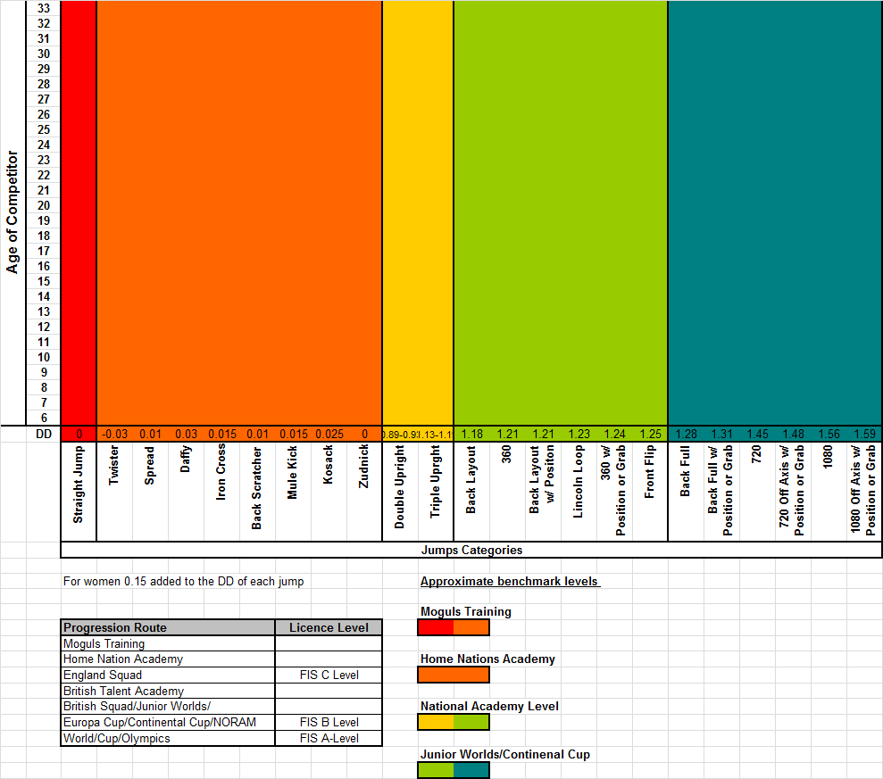

All athletes will now be monitored on their performance in the air using the above tracker.

**5.7 Selection Committee**

SSE Freestyle Chair Martin Carr

SSE Selection Secretary ` Mike Smith

SSE Talent ID Manager Ian Findlay

SSE Selection Rep Becky Hammond

GB Head Moguls Coach Chris David

Academy Moguls Coach Jeff Fozzard

Academy Moguls Coach Ian Danby

**5.8 Athletic Capacity Evaluation**

Each Home Nation has its own athletic capacity evaluation requirements and selected athletes will be subject to meeting those requirements prior to being selected. If an athlete cannot attend he/she will be not be selected until he/she has attended and submitted any relevant documents. This is done to provide baseline figures to chart athletic development over the year.

**6. Appeals Process**

The National Academy appeals processes are structured to conform to UK Sport guidelines.

All appeals must be made in writing, with accompanying evidence and additional information to the National Academy office.

Snowsport England

SportPark

Loughborough University

3 Oakwood Drive

Loughborough

Leicestershire

LE11 3QF

For selections, appeals must be made within 7 days of the announcement of the named athletes. All appeals will be considered on an individual basis. Appeals will first be reconsidered by the original selection committee, who will explain their reasons for the decision to the athlete. If the athlete is not happy with the process or the outcome of the selection committee’s final decision, then the athlete may opt to refer the matter to an internal appeals committee. The Snowsport England appeals chairman will constitute an internal appeal’s committee made up of at least three people, who did not sit on the original selection committee.

If the dispute remains unresolved, it will be submitted for an exclusive, final and binding determination to the Sports Dispute Resolution Panel (SDRP). The National Academy understands that both parties will to undertake and to execute in good faith any decision of the SDRP.