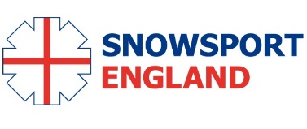

**Snowsport England**

*Freestyle and Snowboard Selection Policy*

**1. Selection Policy**

1.1. This Policy for selection to English Freestyle Squad, shall apply with effect from

February 2016 until further notice.

1.2. The reason for the changes is to provide a clear measurable standard for entry into the Home Nations Academies and National Academies for Moguls, Aerials, Ski Cross and Snowboard Cross.

**2. Aims of the Selection Policy**

2.1. To ensure that fair and just criteria and practices are employed for the selection of

Academy members.

2.2. To support the overall competition and development objectives of Snowsport

England.

2.3. To ensure transparency and accountability in the Selection process.

**3. Process and Timetable**

3.1. Selections will normally be made in, but not limited to, April after the British Freestyle

Championships on snow.

3.2. Meetings other than the April meeting will normally be used only to add to or upgrade

selections already made, and not to de-select individuals.

3.3. All athletes wishing to be considered for selection must submit an online application form.

3.4. Current members of English Teams/Home Nations Academy or National Academy for their respective discipline together with athletes competing internationally will automatically be considered for re-selection/selection **providing an online application is received**.

3.5. Injuries will be taken into consideration for selection/ reselection if received in

Writing alongside online application.

3.6. **Formation and Members of Selection Committee.** The Chairman of the Selection Committee may invite others with specialist knowledge to contribute for part of a meeting depending on the availability of the individual members and the specific areas for which it is selecting. Committee members should be free from external conflicts of interest in the selection process.

**3.7. Code of Conduct.** All athletes will be required to sign and abide by a Code of Conduct, Concussion Protocol and Camp Booking Conditions. Agreement to both of these will be required to submit the online application form.

**4. Selection to Home Nations Academy and National Academy**

**4.1 Home Nations Academy for Ski Cross and Aerials**

4.1.1 Have competed in snow events and training on mountain snow. (Excluding Aerials.)

4.1.2 The selectors will use all resources at their disposal to satisfy themselves that the candidate has the wish and ability to eventually progress in their respective discipline towards British Ski and Snowboard Squads.

4.1.3 Selected athletes should aim to apply for a FIS C licence when eligible.

4.1.4 Athletes agree to sign and abide by the code of conduct.

4.1.6 For **Ski Cross**, athletes must have demonstrated a suitable level of performance whilst competing in the senior (open) category at a British Championships, Home Nation Championships or comparable mountain event (e.g. Audi Ski Cross Tour). Typically the athlete should have achieved a qualifying time within 5% of the race leader at this level, although exceptions may be made at selectors’ discretion.

4.1.7 For **Ski Cross**, athletes must be meet level 2 on the Ski Cross Skills Matrix (see 4.3). Athletes must provide video evidence of their performance or attend a selection camp.

4.1.7 For **Aerials** must be qualified to perform on snow two different manoeuvres

with a Degree of Difficulty of at least 2.0

**4.2 National Academy for Ski Cross and Aerials**

4.2.1 The selectors will use all resources at their disposal to satisfy themselves that the candidate has the wish and ability to eventually progress in their respective discipline towards British Ski and Snowboard Squads.

4.2.2 Should aim to hold a FIS B licence.

4.2.3 Athletes agree to sign and abide by the code of conduct.

4.2.4 Athletes must provide video evidence of their performance or attend a selection camp.

4.2.5 Reselection to the National Academy is dependent on athletes completing an online application form.

4.2.6 For **Ski Cross** those skiers who are Level 3 on the Ski Cross Skills Matrix and show ACE progression (see Appendix 1 – ACE) will be considered for selection. Athletes must also have demonstrable evidence of ski cross performance. For entry to FIS Europa Cup events athletes must have either greater than 35 FIS Freestyle Points in Ski Cross or less than 150 FIS Alpine Points in any Alpine Racing Discipline.

4.2.10 For **Aerials** must have competed at Europa Cup level, equivalent or above

i.e. Must have met the criteria for a FIS B Licence ( refer [www.freestylesnowsports.co.uk](http://www.freestylesnowsports.co.uk) and click on "document download" then select "[BSS Selection Criteria 2014.pdf](https://www.dropbox.com/sh/by1ph8x9p578uyg/AAAClPix_bs7YQ7gG_Db8rjGa/BSS%20Selection%20Criteria%202014.pdf?dl=0)" for download) For clarity not only must the candidate meet the criteria for a FIS B licence, but they must have entered at least one event at this level.

**4.3. SKI CROSS SKILLS MATRIX**

|  |  |  |  |  |  |
| --- | --- | --- | --- | --- | --- |
| **PRIMARY SKILL** | **LEVEL 1** | **LEVEL 2** | **LEVEL 3** | **LEVEL 4** | **LEVEL 5** |
| **PRESSURE** | **POLE JUMPERS** | **POLE JUMPERS IN TUCK** | **STRAIGHT RUN IN ROLLER PACK** | **LINKED TURNS IN ROLLER PACK** | **CAMEL JUMP – IN ROLLER PACK** |
| **EDGING** | **OUTSIDE SKI TURNS** | **ONE SKI SKIING** | **ONE SKI SKIING – LANE CHANGES** | **ONE SKI SKIING THROUGH ROLLER PACK** | **ONE SKI SKIING – ROLLER PACK AND BANKED TURN** |
| **ROTARY** | **STRAIGHT RUN TO SIDESLIP WITH EDGE SET** | **PIVOT SLIPS** | **STRAIGHT RUN TO SIDESLIP TO STRAIGHT RUN** | **HOP TURNS – GS SKIS** | **VERTICAL BRUSH QUICKNESS COURSE** |
| **BALANCE** | **FREESKI WITH POLE USEAGE – GS RADIUS** | **FREESKI – LANE CHANGES** | **FREESKI - HOURGLASS** | **FREESKI – VARIED TERRAIN AND SNOW CONDITIONS** | **FREESKI IN ROLLER PACK AND ADAPT FORE/AFT PLANE OF MOVEMENT** |
| **ROLLER PACK** | **ABSORBS ALL ROLLERS MAINTAINING SKI TO SNOW CONTACT** | **DEMONSTRATES AGILITY WHEN SKIING ROLLERS** | **USES ROLLERS TO GENERATE ACCELERATION OF SKIS** | **ABILITY TO “DOUBLE” ON SELECTED ROLLER PACK** | **DEMOSTRATES TACTICAL AWARENESS WHEN SKIING ROLLERS** |
| **JUMPING** | **CAN SAFELY EXECUTE TAKE-OFF AND LANDING** | **CAN SKI OVER JUMPS IN TRAFFIC AND LAND SAFELY** | **CAN ADAPT AND ADJUST LINE ON TAKE-OFF AND LANDING** | **ADOPTS AERODYNAMIC POSTION WHEN IN AIR** | **CAN ADJUST LENGTH OF FLIGHT BASED ON TACTICAL DECISCIONS** |
| **SKIING IN TRAFFIC** | **CAN SAFELY FOLLOW SKIERS ON A SKI CROSS COURSE** | **CAN IDENTIFY AND EXECUTE DIFFERENT LINE CHOICES EG – QUALIFICATION VS HEATS** | **CAN ADJUST LINE TO DEFEND POSITION ON SKI CROSS COURSE** | **ABILITY TO REACT AND ADAPT LINE BASED ON DECISIONS OF OPPONENTS** | **CAN IDENTIFY AND EXECUTE OVERTAKING OPPORTUNITIES** |

**5. Selection to Home Nations and National Moguls Academies**

**5.1. Home Nations Academy for Moguls**

Selection to the Home Nations Moguls Academy has three components.

**5.1.1 Minimum Standard**

Athletes must be 10 years old or above and have competed in a minimum of two moguls competition either indoor or outdoor in the last twelve months. Athletes who have not competed in moguls may submit evidence of skiing performance, either in another discipline or freeskiing for consideration by the coaches.

**5.1.2 Skiing Skills Evaluation**

Athletes who meet the minimum standard will then be invited to carry out a skills assessment with the Home Nations and National Academy for Moguls Coaches.

**5.1.3 Athletes Skill standards**

Athletes must achieve a minimum of 5 Refinement with a maximum of 1 Acquisition.

|  |  |  |  |
| --- | --- | --- | --- |
| **Skill (to be completed both in and out of the moguls)** | Acquisition (Red) | Consolidation (Amber) | Refinement (Green) |
| **Stance/Balance**  (Athletic balance and stance in a variety of conditions, both on piste and in moguls, demonstrated through a variety of exercises, performed with and without poles, as well as independent single ski exercises) |  |  |  |
| **Edging**  (Athletes must be able to demonstrate the ability to both skid and carve skis in a variety of conditions) |  |  |  |
| **Rotational skills**  (Athletes should demonstrate strong rotational skills in exercises such as braquage and also in basic jumps such as twisters) |  |  |  |
| **Pressure Control**  (Athletes should be able to demonstrate pressure control both in and outside of the moguls) |  |  |  |
| **Turn execution (in moguls)**  (Athletes should demonstrate  control, adaptability and agility in the moguls in order to execute a variety of turns) |  |  |  |
| **Turn execution (out of moguls)**  (Athletes should demonstrate  control, adaptability and agility on piste in order to execute a variety of turns) |  |  |  |
| **Completion of turn**  Athletes should be able to complete a turn appropriately in order to control descent, speed and line without losing control. |  |  |  |
| **Pole planting (in moguls)**  (Athletes should be able to ski moguls planting poles on the face, crest or backside of the moguls. They should also be able to ski moguls without poles) |  |  |  |
| **Tactics – line choice**  (Athletes should be able to maintain a skiing line or switch according to the exercise selected by the coach) |  |  |  |
| **Tactics – adaptation skills**  (Athletes should be able to demonstrate a variety of turns in moguls using the fall fill(line?), shoulders or crest/spine of the moguls) |  |  |  |

**5.1.4** Athletes who complete the above evaluations will then be invited to join the Home Nations Moguls Academy.

**5.1.5** Athletes in the Home Nations Moguls Academy who achieve a judges' score of a minimum of 40.0 in the British Championships, Home Nation Championships or similar snow competitions at a comparable or higher level, including open events run by other nations may apply to British Ski and Snowboard for a FIS C licence to enable them to compete in certain FIS Moguls Competitions.

**5.2 National Academy for Moguls**

**5.2.1** Selection for the National Academy for Moguls is based on athletes’ performance in Moguls competitions. Athletes are expected to achieve;

Three instances of a judges’ score of 50.0 or more in either FIS Race, World Junior Ski Championships, other FIS competition at C level or higher or the British Freestyle Championships. The candidate must also be securely and consistently performing in competition, one rotational air if female and two rotational airs if male. Rotational airs include upright rotations, off axis airs, loops, back and front flips.

## 5.3 Moguls Jump Skills Tracker

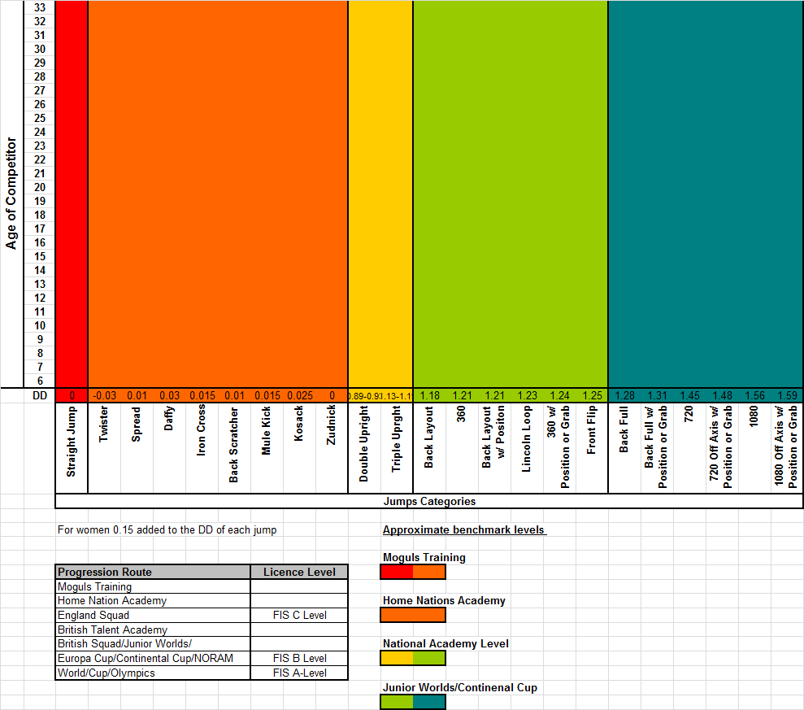

All athletes will now be monitored on their performance in the air using the above tracker.

**5.4. Snowsport England Freestyle and Selection Committee**

Chair of selectors: Martin Carr

Selection secretary: Mike Smith

Snowsport England Talent Lead: Ian Findlay

Moguls Lead: Ian Danby

Park & Pipe Representative: Becky Bennett

Park & Pipe Representative: Gareth Vogan

**5.5. Athletic Capacity Evaluations**

Each Home Nation has its own athletic capacity evaluation requirements and selected athletes will be subject to meeting those requirements prior to being selected. If an athlete cannot attend he/she will be not be selected until he/she has attended and submitted any relevant documents.

**6. Appeals Process**

The National Academy appeals processes are structured to conform to UK Sport guidelines.

All appeals must be made in writing, with accompanying evidence and additional information to the National Academy office.

Snowsport England

SportPark

Loughborough University

3 Oakwood Drive

Loughborough

Leicestershire

LE11 3QF

For selections, appeals must be made within 7 days of the announcement of the named athletes. All appeals will be considered on an individual basis. Appeals will first be reconsidered by the original selection committee, who will explain their reasons for the decision to the athlete. If the athlete is not happy with the process or the outcome of the selection committee’s final decision, then the athlete may opt to refer the matter to an internal appeals committee. The Snowsport England appeals chairman will constitute an internal appeal’s committee made up of at least three people, who did not sit on the original selection committee.

If the dispute remains unresolved, it will be submitted for an exclusive, final and binding determination to Sports Resolutions. Snowsport England understands that both parties will to undertake and to execute in good faith any decision of Sports Resolutions.