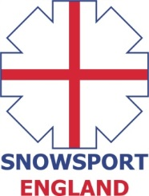
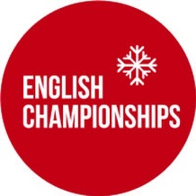

INVITATION
ENGLISH INDOOR SLOPESTYLE CHAMPIONSHIPS
Saturday 6th June, 2015
Chill Factore, Manchester
The 2015 English Indoor SlopestyleChampionships will take place on Saturday 6th of June, 2015 at Chill Factore, Manchester.
Eligibility Criteria
The event is open to all athletes (skiers & snowboarders) who are registered as a performer with a Home Nation (Snowsport England/Snowsport Scotland/Snowsport Wales) and to all members of clubs who are affiliated with a Home Nation.
Athletes who wish to compete who are not registered with a Home Nation or a member of an affiliated club can pay an additional fee of £5 for a daily registration which needs to be paid on the day at the time of registration.
The maximum field size is 120 athletes.
Entry fee
The entry fee for the event - £35
Bib deposit - £10
Online Entry Form - https://secure.jotformpro.com/form/31575745766972

Timetable
8am – 9am – Registration & bib collection
9am – 10.30am – Open Practice
10.30am – 10.45am – Course Shaping
11.am – 3pm – Qualification Runs (ski & snowboard)
3pm – 3.30pm – Course Shaping
3.30pm – 4pm – Practice for finals
4pm – 6pm – Finals
6.15pm – Prize Giving
PRIZE GIVING WILL TAKE PLACE AS SOON AS POSSIBLE AFTER THE COMPLETION OF THE SKI FINALS.
PLEASE NOTE, ALL TIMES SUBJECT TO CHANGE
Overall English Champion title
The overall results will be determined from finals and if two or more athletes from one age group make the final then the age group results will be determined from scores obtained in the finals.
Age Categories(YEAR OF BIRTH)
U12 -2004, 2005, 2006, 2007
U14 - 2003, 2002
U16 - 2001, 2000
U18 - 1999, 1998
U20 - 1997, 1996
Open - 1995 and earlier

