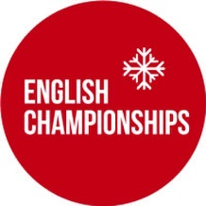
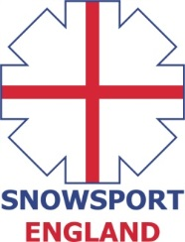

INVITATION
ENGLISH INDOOR SKI and SNOWBOARD CROSS CHAMPIONSHIPS
Saturday 4th June, 2016
Chill Factore, Manchester

The 2016 English Indoor Ski and Snowboard Cross Championships will take place on Saturday 4th of June, 2016 at Chill Factore, Manchester.
Eligibility Criteria
The event is open to all athletes (skiers & snowboarders) who are registered as a performer with a Home Nation (Snowsport England/Snowsport Scotland/Snowsport Wales) and to all members of clubs who are affiliated with a Home Nation.
Athletes who wish to compete who are not registered with a Home Nation or a member of an affiliated club can pay an additional fee of £5 for a daily registration which needs to be paid on the day at the time of registration.
The maximum field size is 100 athletes.
Entry fee
The entry fee for the event - £35
Bib deposit - £10
Online Entry Form - https://form.jotform.com/31575745766972

Timetable SNOWBOARD
8am – 9am – Registration & bib collection
9am – 9.15am – Course Inspection
9.15am – 10am – Open Practice
10.15am – 11.30pm – Snowboard Qualification (2 runs)
12pm – 13.30pm – Finals
SNOWBOARD PRIZE GIVING AFTER FINALS
Timetable SKI
12.30pm – 1.30pm – Registration & bib collection
1.30pm – 1.45pm – Course Inspection
1.45pm – 2.30pm – Open Practice
2.45pm – 4pm – Ski Qualification (2 runs)
4.30pm – 6pm – Finals
PRIZE GIVING WILL TAKE PLACE AS SOON AS POSSIBLE AFTER THE COMPLETION OF THE SKI FINALS.
PLEASE NOTE, ALL TIMES SUBJECT TO CHANGE
Overall English Champion title
The overall results will be determined from OPEN category. If you wish to try and claim the overall English Champion title, then you will need to forgo your age group and enter the open category. If you wish to do this, then please contact the organisers after making your entry.
AGE CATEGORIES 2016

Kids U12: 2005 & later
Youth U16: 2001 – 2004
Junior U21: 1996 – 2000
Open: 1995 – 1987
Masters: 1986 and below

The organisation committee reserve the right to merge age categories if there are low numbers in any particular age categories. This is to ensure a good quality competition for all athletes.

