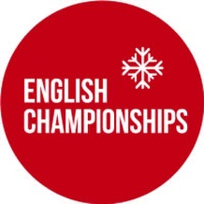
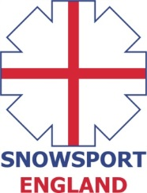

INVITATION
ENGLISH INDOOR SLOPESTYLE CHAMPIONSHIPS
Saturday 25th June, 2016
Chill Factore, Manchester

The 2016 English Indoor Slopestyle Championships will take place on Saturday 25th of June, 2016 at Chill Factore, Manchester.
Eligibility Criteria
The event is open to all athletes (skiers & snowboarders) who are registered as a performer with a Home Nation (Snowsport England/Snowsport Scotland/Snowsport Wales) and to all members of clubs who are affiliated with a Home Nation.
Athletes who wish to compete who are not registered with a Home Nation or a member of an affiliated club can pay an additional fee of £5 for a daily registration which needs to be paid on the day at the time of registration.
The maximum field size is 100 athletes.
Entry fee
The entry fee for the event - £35
Bib deposit - £10
Online Entry Form - https://form.jotform.com/31575745766972

Timetable SNOWBOARD
8am – 9am – Registration & bib collection
9am – 10am – Open Practice
10am – 10.30am – Course Shaping
10.30am – 12.30pm – Snowboard Qualification (2 runs)
1pm – 1.45pm – Finals
SNOWBOARD PRIZE GIVING AFTER FINALS
Timetable SKI
1pm – 2pm – Registration & bib collection
2pm – 3pm – Open Practice
3pm – 3.30pm – Course Shaping
3.30pm – 5.30pm – Ski Qualification (2 runs)
6pm – 6.45pm – Finals
PRIZE GIVING WILL TAKE PLACE AS SOON AS POSSIBLE AFTER THE COMPLETION OF THE SKI FINALS.
PLEASE NOTE, ALL TIMES SUBJECT TO CHANGE
Overall English Champion title
The overall results will be determined from finals and if two or more athletes from one age group make the final then the age group results will be determined from scores obtained in the finals.
AGE CATEGORIES 2016

Kids U12: 2005 & later
Youth U16: 2001 – 2004
Junior U21: 1996 – 2000
Open: 1995 – 1987
Masters: 1986 and below

