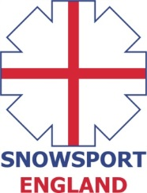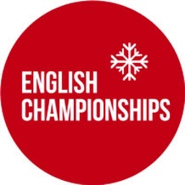

**INVITATION**

**ENGLISH INDOOR MOGULS CHAMPIONSHIPS 2016**

**Saturday 21st May 2016 Chill Factore, Manchester**

The 2016 English Indoor Ski Moguls Championships will take place on Saturday 21st May, 2016 at Chill Factore, Manchester.

**Eligibility Criteria**

The event is open to all athletes who are registered as a performer with a Home Nation (Snowsport England/Snowsport Scotland/Snowsport Wales) and to all members of clubs who are affiliated with a Home Nation.

Athletes who wish to compete who are not registered with a Home Nation or a member of an affiliated club can pay an additional fee of £5 for a daily registration which needs to be paid on at the time of registration.

The maximum field size is 120 athletes.

**Entry fee**

The entry fee for the event - £35

Bib deposit - £10

Online Entry Form - <https://secure.jotformpro.com/form/31575745766972>

**Programme (PLEASE NOTE - ALL TIMES SUBJECT TO CHANGE)**

**3pm – 4pm - Registration and bib issue**

**4.30pm – 5.45pm - Open Training**

**5.45- 6pm Course Preparation**

**6pm -7.30pm Single Moguls Competition**

**7.30-8.00pm Single Moguls Finals**

**8pm -8.30pm Course preparation for Duals**

**8.30pm-9.30pm Dual Moguls finals**

**10.pm Prize Giving (or earlier)**

**Single Format**

All athletes will compete in the qualifying round. If there is time, depending on the number of entries, there may be 2 qualification runs with the best counting. The number of athletes that progress to the finals will depend on the number of entries with separate male and female finals.

**Duals**

The dual moguls will be seeded from the results of the single moguls overall competition. All athletes will have the chance to compete head to head, male and female competitors separately.

**Overall English Champion title**

The title of English Champion will be awarded to whoever has the highest score irrespective of their age category.

All age groups will compete together. Winners of age categories will only be determined after the competition has been completed and will be taken from the final results list. Anyone not making finals will have the highest result from qualification used to calculate their age category result.

**Contacts**

Martin Carr– Championships Secretary and Chief of Competition [martin.carr@freestylesnowsports.co.uk](mailto:martin.carr@freestylesnowsports.co.uk)

Ian Danby – Chief of Course [imdanby@btinternet.com](mailto:imdanby@btinternet.com)

Ian Findlay – Race Director [i.findlay@snowsportengland.org.uk](mailto:i.findlay@snowsportengland.org.uk)

Peter Bates– Head Judge [pjbates@blueyonder.co.uk](mailto:pjbates@blueyonder.co.uk)