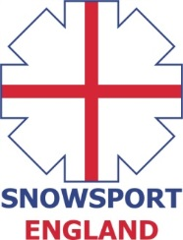
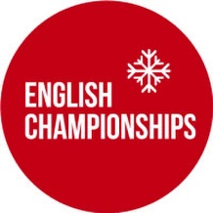
INVITATION
ENGLISH INDOOR MOGULS CHAMPIONSHIPS 2017
Saturday 20th May 2017 Snowzone, Caslteford
The 2017 English Indoor Ski Moguls Championships will take place on Saturday 20th May, 2017 at Snowzone, Castleford.
Eligibility Criteria
The event is open to all athletes who are registered as a performer with a Home Nation (Snowsport England/Snowsport Scotland/Snowsport Wales) and to all members of clubs who are affiliated with a Home Nation.
Athletes who wish to compete who are not registered with a Home Nation or a member of an affiliated club can pay an additional fee of £5 for a daily registration which needs to be paid at the time of registration.
The maximum field size is 120 athletes.
Entry fee
The entry fee for the event - £35
Bib deposit - £10
Online Entry Form - https://secure.jotformpro.com/form/31575745766972

Programme (PLEASE NOTE - ALL TIMES SUBJECT TO CHANGE)

11:00 - 12:00 Registration and bib issue
12:00 - 13:45 Open Training
13:45 – 14:00 Course Preparation
14:00 – 15:30 Single Moguls qualification
15:45 – 16:15 Single Moguls Finals
16:45 Prize Giving (or earlier)

Single Format

All athletes will compete in the qualifying round. Depending on the number of entries, there may be 2 qualification runs with the best counting. The number of athletes that progress to the finals will depend on the number of entries with separate male and female finals.

Overall English Champion title
The title of English Champion will be awarded to whoever has the highest score irrespective of their age category.
All age groups will compete together. Winners of age categories will only be determined after the competition has been completed and will be taken from the final results list. Anyone not making finals will have the highest result from qualification used to calculate their age category result.

Contacts
Martin Carr– Championships Secretary and Chief of Competition martin.carr@freestylesnowsports.co.uk
Ian Danby – Chief of Course imdanby@btinternet.com
Ian Findlay – Race Director i.findlay@snowsportengland.org.uk
Peter Bates– Head Judge pjbates@blueyonder.co.uk

