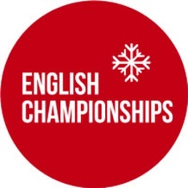
ENGLISH SLOPESTYLE CHAMPIONSHIPS
START ORDER
U12F/M > U16 F/M > U21 F/M > OPEN F/M > MASTERS F/M
All categories will complete their first run and then the process will be repeated for run 2.
QUALIFICATION
Each athlete will have two qualification runs. Athletes best score from these two qualification runs will be used to determine the finalists.
FINALS
The TOP 12 MALES and TOP 6 FEMALES from qualification will proceed to the finals.
OVERALL WINNERS
The overall English Championships titles and overall finishing positions will be awarded based on scores from finals.

AGE GROUPS PLACINGS
If two or more athletes from the same age group progress to finals, the final age group rankings will be determined based on the scores from finals. By making finals, these two or more athletes are guaranteed the top two or more placings in their age group but the final order will be determined from scores in the final.
If only one athlete from an age group progresses into finals then the age group result will be determined from qualification scores with this one athlete guaranteed the win in their respective age group.
Example: Rider A got 60 in qualification, B got 50 and C got 40. Riders A and B went through to the final, with B scoring 35 in the final and A scoring 30. In their age category, they finished B in first, A in second and C in third.

